BAN240 · ORIGINAL MANGA CHARACTER · OFFICIAL DOSSIER

Yuna
Manga Character Profile Dossier
Park Yuna (박유나) | Toronto Metropolitan University | Business Analytics, 2nd Year
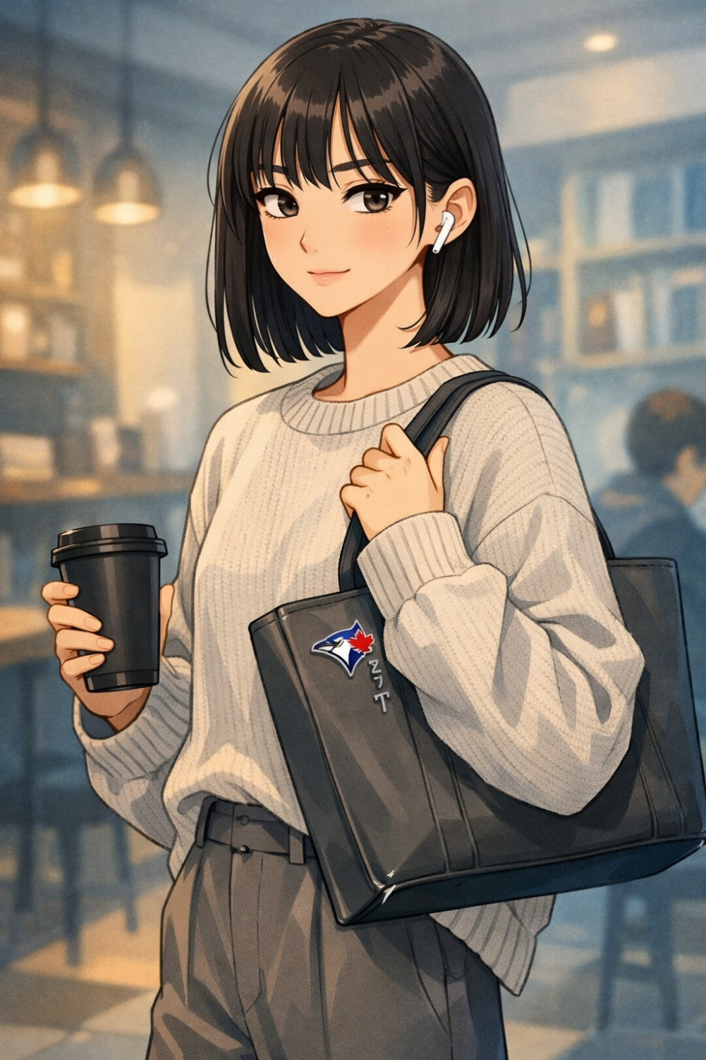
Precision | Composure | Wit | Competitiveness | Loyalty | Danger in LoL
★★★★★ | ★★★★★ | ★★★★☆ | ★★★★★ | ★★★★☆ | ★★★★★

SECTION 01

Biographical Overview
Yuna is a fully realized manga character — a quietly precise Korean international student whose calm, composed exterior contains a razor-sharp wit, a ferociously competitive streak, and an inner world far richer than most people get to see. She is not shy — she is selective. She speaks when she has something worth saying, which turns out to be often.
She arrived in Toronto having already researched the best study cafés, the fastest subway routes, and the most underrated ramen spots within walking distance of campus. She did not come here to find herself. She came here to build something.

"The escalator ends. This was knowable in advance."
— Yuna, on people who stop at the top of escalators

SECTION 02

Demographics & Basic Information
Full Name | Park Yuna (박유나) — family name first in Korean convention; goes by Yuna in Canada
Age | 22
Gender | Female
Ethnicity | Korean
Hometown | Seoul, South Korea — Mapo-gu district
Current City | North York, Ontario, Canada
Living Situation | One-bedroom apartment shared with a single Korean roommate — clean, organized, decorated with one Ghibli poster and a small succulent collection
Immigration Status | International student visa
Occupation | Full-time undergraduate student
University | Toronto Metropolitan University (TMU)
Program | Business Analytics
Year | 2nd Year
Course | BAN240

SECTION 03

Physical Appearance & Manga-Style Portrait Description
Height | 5'5"
Build | Slender and upright — excellent posture; moves with a quiet economy of motion
Hair | Straight, dark brown/black, shoulder-length with a neat see-through fringe; occasionally tucked behind one ear when concentrating; rarely styled differently — consistency is a feature, not a limitation
Eyes | Dark, slightly almond-shaped, calm and attentive; "reading you in real time" energy; sparkle-eye mode activates for League of Legends ranked matches, Blue Jays baseball, and perfectly made ramyeon
Skin Tone | Light cool-toned
Typical Outfit | Neutral-toned oversized knit or crewneck sweater, wide-leg trousers or straight-cut jeans, clean white or beige sneakers — effortlessly put-together in a way that looks unconsidered but is not
Accessories | Structured tote bag (carries laptop, tabbed notebook system, skincare pouch, and emergency ramyeon cup); wireless earbuds; a single enamel Blue Jays pin on the tote — her one visible act of local loyalty

Manga Art Style Notes

• Signature Expression: Calm half-lidded look, one eyebrow raised — the "I already knew that" face
• Sparkle Eyes: Triggered by LoL ranked promos and KBO highlight reels
• Internal Monologue Panels: Rendered in cool blue-grey tones
• Chibi Mode: Triggers when someone mispronounces her name
• Dead Eyes Panel: Reserved exclusively for when someone says Excel is good enough for data analysis

SECTION 04

Personality & Quirks
- Communication Style: Speaks in complete, well-constructed sentences — no filler words; reads as intimidating to some, deeply reassuring to others
- Dry Humour: Lands so quietly people sometimes don't register it until thirty seconds later; she never repeats a joke
- The Ramen List: Maintains a ranked list of Toronto ramen spots in her notes app, updated with brief tasting annotations — treated with the same rigour as academic notes
- Korean Time: Arrives 10 minutes early to everything; quietly regards anyone 10 minutes late as actually 20 minutes late
- Skincare: Non-negotiable 7-step routine, morning and night — considers this discipline, not vanity
- Coffee Order: Black; views flavoured syrups in coffee with quiet, personal disappointment
- Texting Style: Either one precise sentence or a detailed voice note — no in-between
- LoL: Will destroy you in a ranked match and say nothing more than "gg" afterwards
- Baseball: Follows KBO via the Korea Baseball app during Canadian season overlap; adopted the Blue Jays with genuine, if newly acquired, loyalty
- Excel Sheets: Names every sheet; considers unnamed sheets a sign of disordered thinking

SECTION 05

Hobbies & Interests
# | Hobby | Description
1 | League of Legends | Support main (Lulu, Nami) in high Gold / low Platinum ranked. Watches the LCK (Korean LoL esports league) religiously. Has opinions about the meta that are specific and correct.
2 | Baseball | Grew up watching KBO with her father. Follows KIA Tigers (KBO) as home team and Toronto Blue Jays as Canadian adoption. Understands the sport at a statistical level that surprises people.
3 | Badminton | Played at a competitive club level in Seoul; now plays recreationally at the TMU gym. Still plays at a level that surprises recreational opponents.
4 | Korean Cooking | Specializes in one-pot and quick-prep dishes for student life: kimchi jjigae, doenjang jjigae, tteokbokki, and a ramyeon upgrade ritual (egg, green onion, cheese, gochugaru) refined into near-ceremony.
5 | Skincare & Beauty | Follows ingredient science, reviews actives and formulations, and maintains a curated 7-step routine. Occasionally consulted by her friend group as the resident expert.
6 | Café Hopping | Scouts and ranks cafés for study potential (lighting, outlet access, noise level, coffee quality, aesthetic). Photographs setups and drinks for a private Instagram with 11 followers she has never mentioned to anyone on campus.

SECTION 06

Sports

Role | Sport & Detail
Primary Fan Sport | Baseball — KBO devotee (KIA Tigers); Toronto Blue Jays adopted fan with a single enamel pin as proof; watches via the KBO app and MLB app simultaneously during season overlap
Primary Participatory Sport | Badminton — Competitive club background from Seoul; plays recreational doubles at TMU gym; visibly holds back against casual opponents
Secondary Fan Sport | LoL Esports (LCK) — Treats the LCK season with the same engagement others give traditional sports leagues; follows team rosters, patch updates, and tournament brackets
Anime Sports Influence | Haikyuu!! — Gave her a new respect for volleyball as a strategic sport; her background in badminton made the spatial and reading-the-opponent elements feel familiar; she acknowledges it is a good manga with the tone of someone awarding a grade

SECTION 07

Fandoms
# | Fandom | Notes
1 | LCK / League of Legends Esports | Primary esports fandom. Follows T1 and Gen.G. Has strong feelings about specific roster decisions she will not elaborate on unprompted.
2 | KIA Tigers (KBO) | Home team loyalty. Can discuss KBO history and specific player arcs in detail. This fandom is deeply connected to her father and watching games growing up in Seoul.
3 | Toronto Blue Jays | Local adoption. Owns one pin. Genuinely learns the roster each season. Considers this integration, not assimilation.
4 | Studio Ghibli | Deep catalogue loyalty. Has a Spirited Away poster. Considers Ghibli films structurally perfect and will defend this position. My Neighbour Totoro is comfort content; Nausicaä is her favourite.
5 | NewJeans | K-pop group of choice. Appreciates the production quality and restrained aesthetic more than the spectacle. Owns one album.
6 | Korean Cinema / Parasite | Follows Korean film and director careers. Bong Joon-ho is the benchmark against which other directors are measured.
7 | Haikyuu!! | Respected and acknowledged. Not her primary fandom, but she owns the argument that it handles sports psychology better than most sports films.
8 | Café Instagram Accounts | A private, curated fandom of aesthetic café accounts across Seoul, Tokyo, and Toronto. Her reference library for personal café scouting.

SECTION 08

Commute & Daily Life

Commute Route
Home Base | North York, Ontario — near Sheppard-Yonge Station
Route | Walk to Sheppard-Yonge Station → Line 1 southbound → alight at Dundas or Queen → short walk to TMU campus
Duration | ~30–35 minutes each way — the shortest commute in the cohort. This was not an accident.
Commute Mood | Earbuds in, LCK VOD review or baseball highlights on her phone, one hand on her tote strap. She is the person who positions herself exactly at the subway door that aligns with the exit stairs — every time, without appearing to try.
Signature Move | Already seated at her preferred café spot 20 minutes before class starts. Laptop open, notebook tabbed, coffee placed at a specific angle to avoid glare — all completed before most people have found the building.
Transit Pet Peeve | "The escalator ends. This was knowable in advance."

On-Campus Routine
- First to claim the best-lit table in the library study area
- Colour-coded notes open within 90 seconds of sitting
- Small pouch of snacks placed to one side: individually wrapped Korean crackers, a single piece of dark chocolate
- Earbuds out during class; in between

Daily Schedule (After Campus)

Time | Activity
Midday | Meticulously packed bento-style lunch (rice, banchan in small containers, always fruit) or Korean-adjacent spots near campus. Evaluates all sandwiches with visible internal effort to be fair.
Afternoon | One structured study block after class
Before 7 PM | Home — cook, decompress with a KBO game in the background
Evening | Complete skincare routine
9 PM onward | LoL ranked session — ends at a time she declines to specify

SECTION 09

Character Role & Narrative Function
Yuna is the precision instrument of the ensemble — the character whose calm competence makes the group more capable than the sum of its parts, and whose arc is the quiet revelation that competence is not the same as connection. In a school manga, she is the one who fixes the plan when it breaks, identifies the flaw in the logic before anyone else, and leaves without making it a moment.
Her growth is not about becoming warmer — she is warm, in the register she chooses — it is about allowing the people around her to see it. Her most powerful scenes are the small ones: the ranked game she wins and says nothing, the bento she makes with two extra portions for friends who mentioned being tired, the Blue Jays game she watches alone at 1 AM because her father is also watching it from Seoul, and they are not talking but they are, in some sense, together.
Narrative Archetype: The Precision Instrument
Arc Theme: Competence is not the same as connection — and choosing to be seen is its own form of courage
Most Powerful Scene Type: The small, quiet ones — extra bento portions; a 1 AM baseball game shared across a continent
Growth Direction: Not toward warmth (already there) — toward visibility

Yuna — BAN240 Manga Character Sheet | Park Yuna (박유나) | Toronto Metropolitan University
Original character created for BAN240 · All content original · Document generated June 2026

